Colab & Github

* To load a notebook from github
  + The first thing you see when loading the colab website is this. Clik on Github. If you don’t see this image, go to file, open notebook.

* + In search, copy this: <https://github.com/santiagoalonso/Cognicion-Bayesiana/> and press enter. Go all the way down to “Notebooks_slides/” (WARNING: do not confuse with “Notebooks_slides/ipynb_checkpoints/”) and look for the notebook for the current session (I can tell you which one). Click on it.

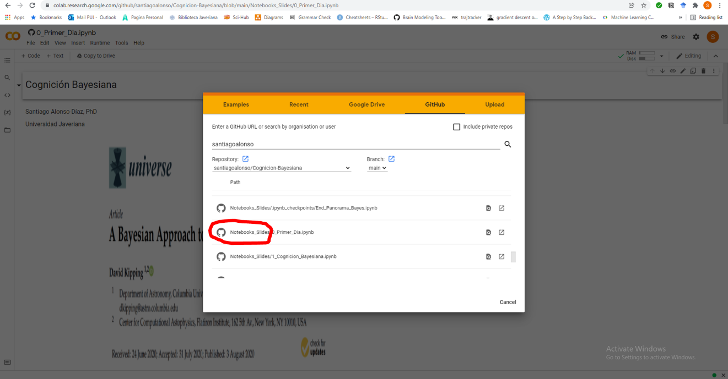

* To load data from github
  + In some notebook’s cells, we will load data. In colab, you will need to change the file pointer to an https one.

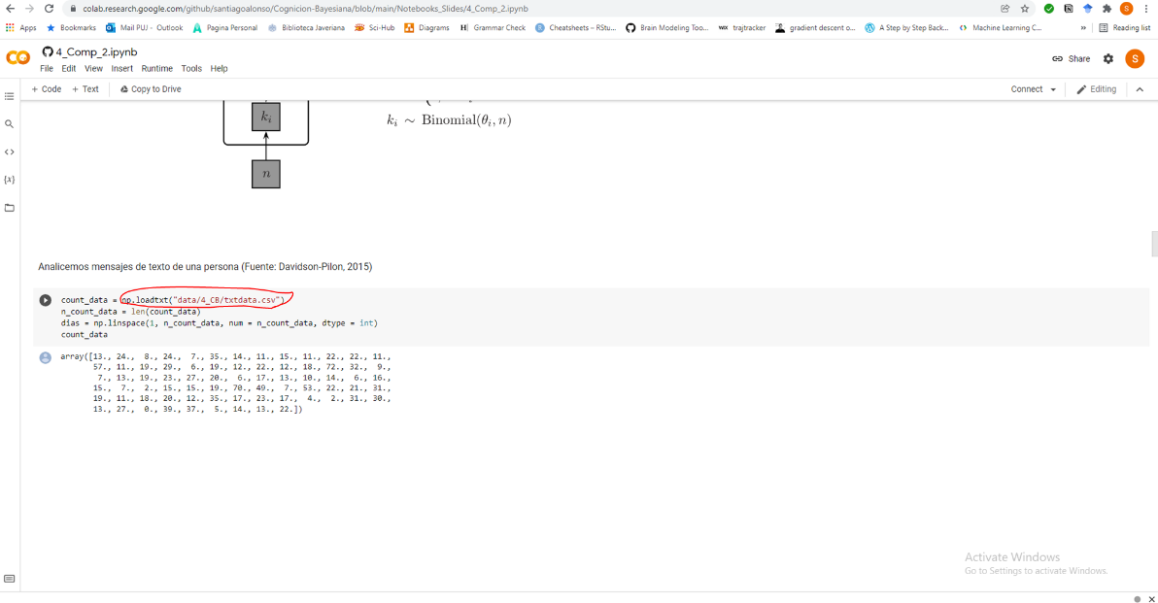

* + Most data in the course is in <https://github.com/santiagoalonso/Cognicion-Bayesiana/tree/main/Notebooks_Slides/data>
  + For example, in the previous image we load a file called “data/4_CB/txtdata.csv”. If you are in colab, you just change that address with the one from github. So, go to the github address and click on the folder “4_CB”

Then click on the desired data, in this case txtdata.csv

Then click on “Raw”

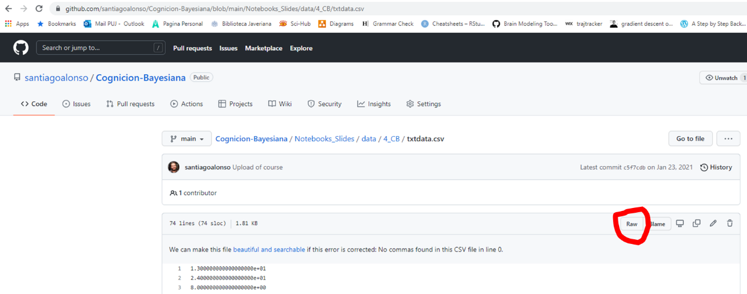

Then copy the html address and replace the previous folder pointer. That is, before it was “data/4_CB/txtdata.csv”, and now it should be the html address “https://raw.githubusercontent.com/santiagoalonso/Cognicion-Bayesiana/main/Notebooks_Slides/data/4_CB/txtdata.csv”

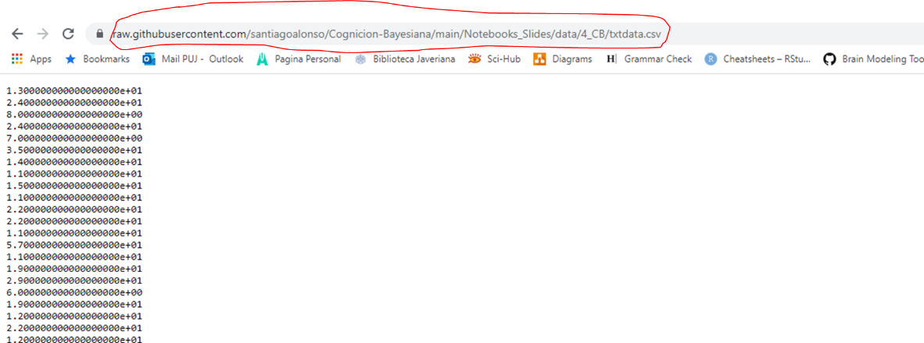

* Installing python libraries in colab
  + In a code cell, write this: pip install NAME_OF_PACKAGE.
  + For example, to install the pingouin package write pip install pingouin